Workload Consolidation using Task Scheduling Strategy in Cloud Computing

Principal Author^{1*}, First Author² and Second Author^{1,2}

^{1*}Department, University Name, City, Country, Pincode, orcid id

²Department, University Name, City, Country, Pincode, orcid id

Corresponding Author E-mail: Corresponding author@gmail.com

Orcid ID: 0000-000X-XXXX-XXXX

Abstract
The abstract should be concise and elicit a clear indication of the objective, scope, and results of the paper in order for readers to determine if the full text will be of particular interest to them. All the abbreviations must be spelled out fully when first mentioned in the abstract of the report.
Keywords
The authors must provide up to 6 keywords for indexing purposes. Only established abbreviations may be proposed as keywords. All the keywords must be arranged in alphabetical order.
Introduction
In this part, there should be a concise review of the problem, the relevant methodologies and a clear establishment of the goal(s) of the study.
Material and methods
This section consists of elaboration of the objective of the study, and step-by-step details of the experiment. The following are to be specified:

- The original names of instruments and reagents.
- Manufacturer’s name (company, country).
- Source from which the particular strain has been obtained.

Table 1: Legend for table 1
Title | Value 1 | Value 2 | Value 3
Description 1 | 100 | 100 | 100
Description 2 | 1m | 100m | 500m
Description 3 | 240 | 32767 | 250
Description 4 | 250 Kbps | 2.1 Mbps | 450 Mbps
Description 5 | 5MHz | 902MHz | 160MHz

Results and Discussion
The results and discussion section should have a brief account of the so-obtained experimental data, along with tables and figures. The section should be completed with a fulfilling conclusion, addressing the questions and problems raised in the Introduction section.
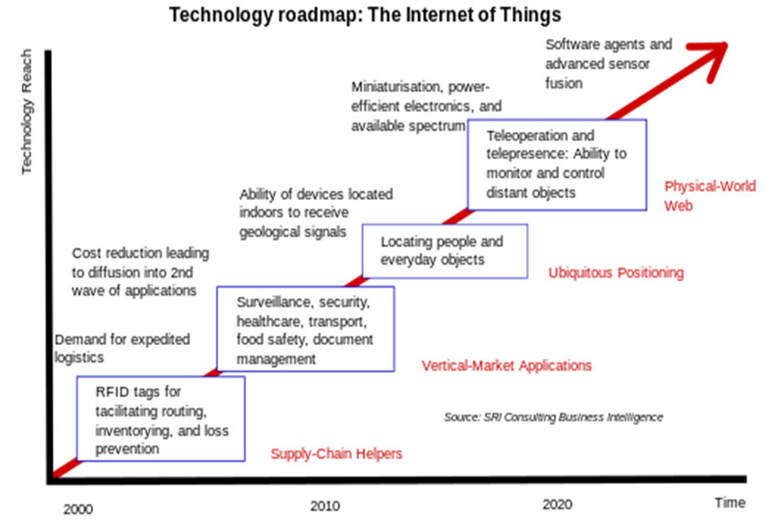
Figure 1: Legend for figure 1

Figures and Tables
The tables should be marked with a number and a title. The figures must contain the captions. Figure/Photos submitted must be of high resolution. Proper reference must be given for the figures and photos.

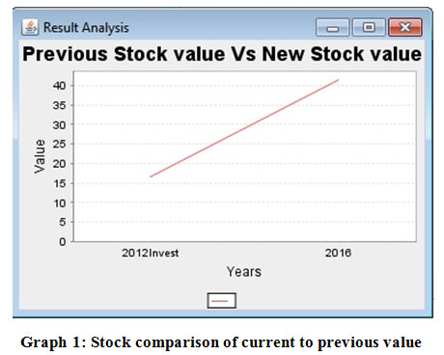
Graph 1: Legend for graph 1
Conclusion
The conclusion should summarize the major findings of the investigation. The purpose or hypothesis of the study stated earlier should be addressed.
Acknowledgement
This section must appear before References. The Acknowledgments should contain the names of individuals, organizations and funding agencies that aided in underwriting and reporting the particular work.
Conflict of Interest
All authors are requested to disclose any conflict of interest including honorarium, grants, membership, employment, ownership of stock or any other interest or non‐financial interest such as personal or professional relation, affiliation and knowledge of the research topic.
Funding Source
Please provide the source of financial support if any.

Reference Format

- Burwen D. R, Banerjee S. N and Gaynes R. P. Foundations of Machine Learning spring 2007, Courant Institute of Mathematical Science New York University.,1994; 170: 1622-1625.

Note: It is to be ensured that every reference cited in the text is present in the reference list, and vice versa.

